RETAIL SALES PERFORMANCE ANALYSIS DASHBOARD
Business Analysis Report
Personal Project | 2026

Dananjana Bandara
BSc (Hons) in Information Technology
Specialization: Information Systems Engineering
Sri Lanka Institute of Information Technolog

CONTENTS
1. INTRODUCTION 4
2. BUSINESS PROBLEM 4
3. BUSINESS OBJECTIVES 5
4. DATASET DESCRIPTION 6
5. DATA PREPARATION AND CLEANING 7
5.1 Data Type Validation 7
5.2 Data Quality Validation 7
5.3 Power Query Transformation 8
6. Data Modeling 8
7. DAX Measures and KPI Development 9
7.1 Total Sales 10
7.2 Total Profit 10
7.3 Total Orders 10
7.4 Average Sales Per Order 10
7.5 Profit Margin 11
8. DASHBOARD DEVELOPMENT 11
8.1 Executive Dashboard 11
8.2 Sales Analysis 13
8.3 Customer & Product Insights 14
8.4 Business Insights 16
9. KEY BUSINESS FINDINGS 17
9.1 Overall Business Performance 17
9.2 Regional Performance 17
9.3 Category Performance 18
9.4 Customer Segment Performance 18
9.5 Shipping Performance 18
9.6 Discount and Profitability 19
10. BUSINESS RECOMMENDATIONS 19
10.1 Investigate Central Region Profitability 19
10.2 Maintain and Learn from West Region Performance 19
10.3 Prioritize High-Performing Product Categories 20
10.4 Review Discounting Strategy 20
10.5 Develop Customer-Focused Strategies 20
10.6 Monitor Regional KPIs Regularly 21
11. CONCLUSION 21

INTRODUCTION
Retail organizations generate large volumes of transactional data through customer orders, product sales, shipping activities, and regional operations. However, raw transaction data alone does not provide an efficient way for decision-makers to monitor business performance, identify trends, or recognize areas requiring attention.
The Retail Sales Performance Analysis Dashboard was developed as a personal Business Intelligence project using Microsoft Power BI. The project transforms retail transaction data into an interactive analytical dashboard that provides insights into sales performance, profitability, customer segments, regional performance, product categories, shipping methods, and sales trends over time.
The solution incorporates data preparation and transformation using Power Query, data modeling, DAX-based measures and KPIs, and interactive Power BI visualizations. Four analytical dashboard pages were developed: Executive Dashboard, Sales Analysis, Customer & Product Insights, and Business Insights.
The primary purpose of the solution is to support data-driven decision-making by presenting business information in a clear and interactive format. Rather than simply displaying raw sales figures, the dashboard enables users to compare performance, identify trends, investigate profitability, and explore business performance through interactive filtering.

BUSINESS PROBLEM
Retail sales data can contain valuable information about customers, products, regions, sales revenue, profitability, discounts, and shipping activities. However, analyzing large amounts of transactional data manually can make it difficult for decision-makers to obtain a clear and timely understanding of business performance.
Several business questions may be difficult to answer directly from raw transaction records:
- What is the overall sales and profitability performance?
- Which regions generate the highest sales?
- Which regions generate the strongest profit margins?
- Which product categories contribute most to revenue?
- Which products and customers generate the highest sales?
- How does profitability vary across product sub-categories?
- How do sales and profit change over time?
- Which customer segment contributes the most sales?
- How are different shipping methods performing?
- Is there a relationship between discount levels and profitability?
Without an integrated analytical view, stakeholders may need to manually review or combine information from different parts of the dataset. This can increase the time required for analysis and make it harder to identify important trends and performance differences.
Therefore, the business problem addressed by this project is the lack of a centralized, interactive analytical solution for monitoring retail sales performance and converting transactional data into actionable business insights.

BUSINESS OBJECTIVES
The main objective of the project was to develop an interactive Business Intelligence dashboard that enables stakeholders to analyze retail sales performance and support data-driven decision-making.
The specific objectives were:
- Analyze overall retail sales and profitability performance.
- Develop executive-level KPIs for monitoring business performance.
- Identify sales performance differences across regions.
- Analyze sales contribution across product categories and sub-categories.
- Identify the highest-performing products and customers.
- Analyze customer segment performance.
- Examine sales and profit trends over time.
- Analyze sales performance by shipping method.
- Investigate the relationship between discount levels and profitability.
- Provide interactive filtering capabilities for business users.
- Present analytical findings in a clear and management-friendly format.
- Develop business recommendations based on the identified performance patterns.

DATASET DESCRIPTION
The project uses a retail sales transaction dataset containing information related to customer orders, products, geographic regions, financial performance, customer segments, discounts, and shipping.
The major fields used during the analysis include:
Field | Description
Order Date | Date on which an order was placed
Customer Name | Customer associated with the transaction
Product Name | Product associated with the transaction
Category | High-level product category
Sub-Category | More detailed product classification
Region | Geographic sales region
State/Province | Geographic location of the transaction
Segment | Customer segment
Ship Mode | Shipping method used for the order
Sales | Revenue generated from the transaction
Profit | Profit generated from the transaction
Discount | Discount applied to the transaction
Quantity | Quantity associated with the transaction
The dataset supports analysis across several business dimensions, including time, geography, customers, products, sales, profitability, and shipping.
Before creating the dashboard, the dataset was reviewed to confirm that important categorical and numerical fields were suitable for analysis.

DATA PREPARATION AND CLEANING
Data preparation was performed before developing the dashboard to improve data consistency and ensure that the resulting analysis was reliable.
The data preparation process included reviewing the dataset structure, checking column types, validating categorical values, and ensuring that numerical and date fields were appropriate for analysis.

Data Type Validation
The relevant fields were reviewed to ensure that:
- Date fields were recognized as dates.
- Sales and Profit were treated as numerical values.
- Discount and other numerical attributes were represented appropriately.
- Categorical fields such as Region, Category, Segment, and Ship Mode were treated as categorical data.
Correct data types were important because Power BI uses field types to determine how values are aggregated and visualized.

Data Quality Validation
The dataset was reviewed for consistency in important categorical fields. In particular, values such as:
- Technology
- Office Supplies
- Furniture
were validated as product categories.
Similarly, the four regions:
- Central
- East
- South
- West
were confirmed as the expected regional categories.

Power Query Transformation
Power Query was used within Power BI to prepare the dataset for analysis. The transformation stage provided a controlled process for reviewing and preparing the source data before it was used in the analytical model.
The objective of this stage was not to alter valid business information unnecessarily, but to ensure that the dataset was structured consistently for reporting and analysis.

Data Modeling
After data preparation, the dataset was structured within Power BI to support analytical reporting.
The model was designed to allow business measures to be evaluated across dimensions such as:
- Date
- Region
- State/Province
- Category
- Sub-Category
- Customer
- Customer Segment
- Ship Mode
The analytical model supports filtering and aggregation across these dimensions while allowing measures such as Sales, Profit, Orders, Average Sales per Order, and Profit Margin to respond dynamically to user selections.
The Power BI model was structured around the Orders transaction table, with related supporting tables used to provide additional business information. The model enables sales and profitability measures to be analyzed across different business dimensions and supports interactive filtering throughout the dashboard.

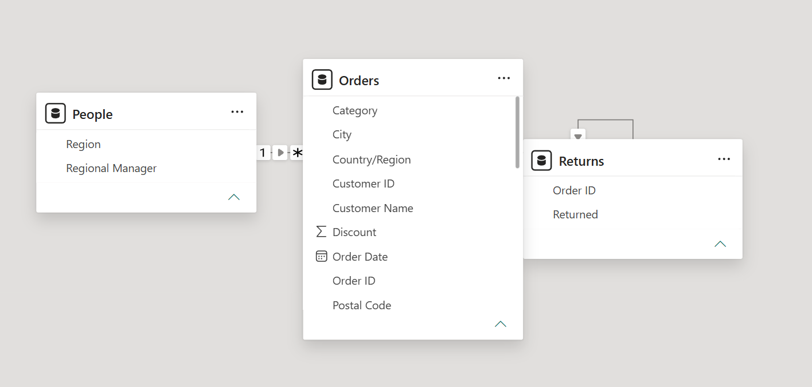
Figure 6.1: Power BI Data Model
The resulting model provides the foundation for the interactive dashboard and enables users to analyze the same business measures from multiple perspectives.

DAX Measures and KPI Development
DAX measures were developed to provide reusable calculations for the dashboard.
Rather than placing raw numerical columns directly into every visual, measures were used to standardize the calculation of important business indicators.
The primary KPIs developed for the project were:
KPI | Business Purpose
Total Sales | Measures overall revenue generated
Total Profit | Measures overall profit generated
Total Orders | Measures order volume
Average Sales per Order | Indicates the average sales value associated with an order
Profit Margin | Measures profitability relative to sales

Total Sales
Total Sales provides a high-level measure of the revenue generated across the dataset.
Total Sales = SUM(Orders [Sales])
Business purpose:
Allows stakeholders to monitor overall sales performance and compare revenue across regions, categories, products, customers, and time periods.

Total Profit
Total Profit measures the overall profit generated from the transactions.
Total Profit = SUM(Orders[Profit])
Business purpose:
Provides a profitability perspective in addition to revenue, allowing stakeholders to identify whether high sales are also associated with strong financial performance.

Total Orders
Total Orders provides an indication of order volume.
Total Orders = DISTINCTCOUNT(Orders [Order ID])
Business purpose:
Allows stakeholders to distinguish between changes in sales value and changes in transaction volume.

Average Sales Per Order
Average Sales per Order provides an indication of the average sales value associated with each order.
Average Sales per Order = DIVIDE([Total Sales], [Total Orders])
Business purpose:
Helps evaluate purchasing value and provides additional context when interpreting total sales and order volume.

Profit Margin
Profit Margin measures profit relative to sales.
Profit Margin = DIVIDE([Total Profit], [Total Sales])
Business purpose:
Provides a more meaningful profitability comparison across regions and other business dimensions because it considers profitability in relation to the revenue generated.

DASHBOARD DEVELOPMENT
The Power BI solution was organized into four analytical pages. Each page has a different purpose so that the report provides both high-level executive monitoring and detailed analysis.

Executive Dashboard
The Executive Dashboard provides a high-level overview of retail business performance.
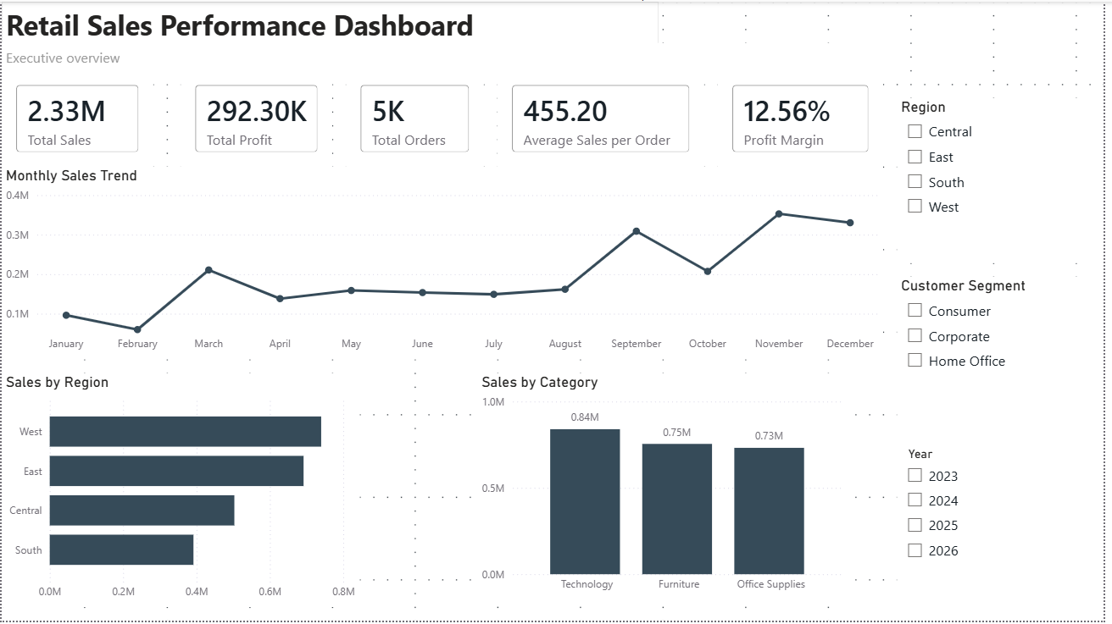
Figure 8.1: Executive Dashboard
The page contains five primary KPIs:
- Total Sales
- Total Profit
- Total Orders
- Average Sales per Order
- Profit Margin
A Monthly Sales Trend visualization was included to provide a time-based view of sales performance.
The page also includes:
- Sales by Region
- Sales by Category
- Region slicer
- Customer Segment slicer
- Year slicer
The purpose of this page is to provide executives or management users with a quick overview of current business performance without requiring them to inspect individual transactions.

Sales Analysis
The Sales Analysis page provides more detailed analysis of sales performance.
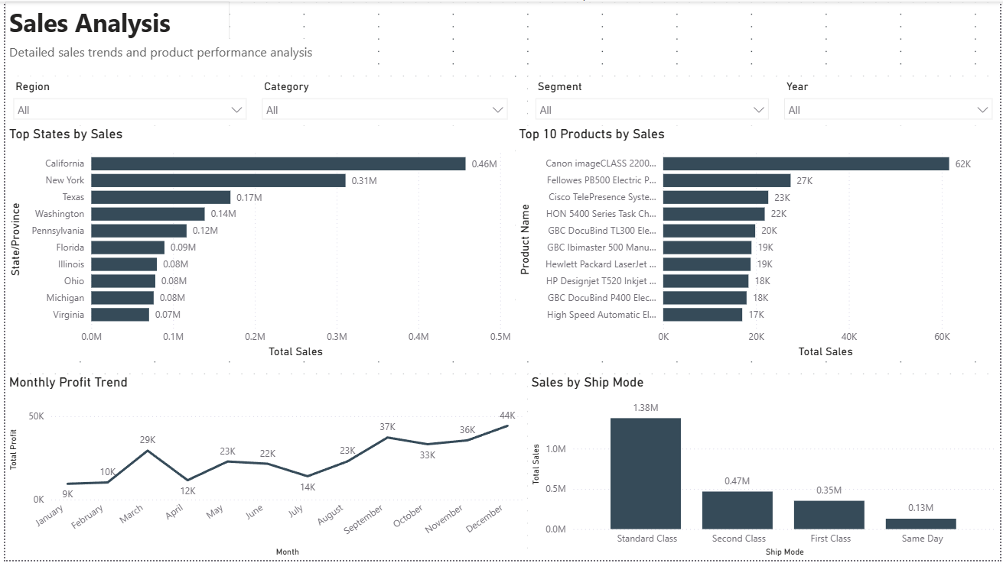
Figure 8.2: Sales Analysis Dashboard
The page contains:
Sales by State
This visualization identifies the highest-performing states based on sales and provides a geographic perspective of revenue performance.
Top 10 Products by Sales
This visualization identifies the products generating the highest sales values.
This can help stakeholders understand which products contribute significantly to revenue.
Monthly Profit Trend
This visualization provides a time-based view of profitability and allows users to identify periods of stronger or weaker profit performance.
Sales by Ship Mode
This visualization compares sales performance across shipping methods and provides additional operational context.
Interactive filters for Region, Category, Segment, and Year allow users to analyze these visuals under different business conditions.

Customer & Product Insights
The Customer & Product Insights page focuses on customer contribution, product profitability, and detailed transaction analysis.
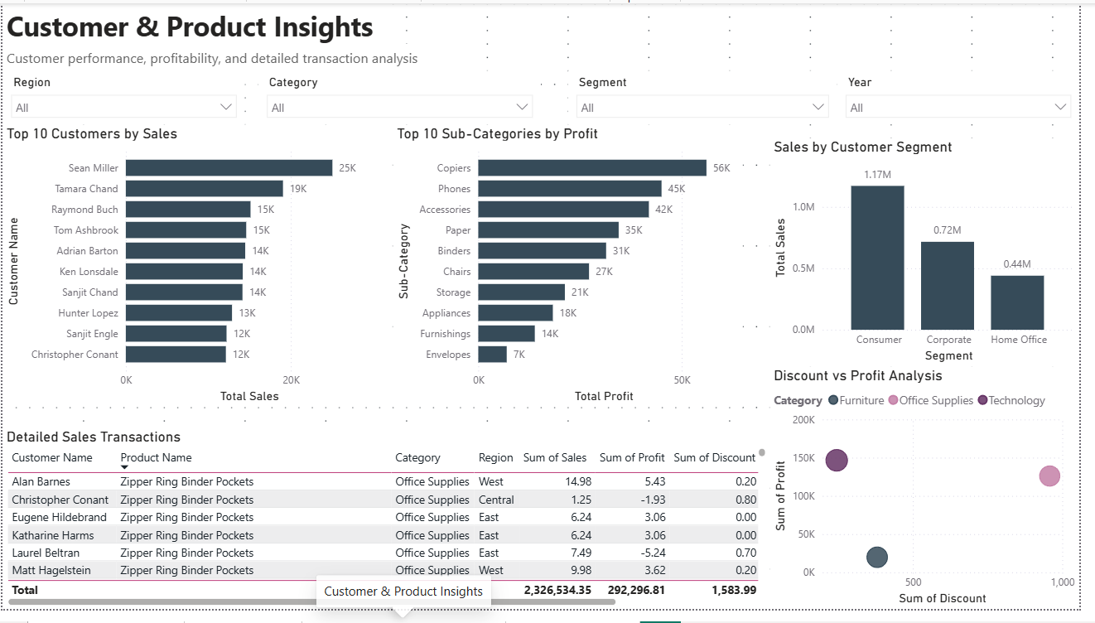
Figure 8.3: Customer & Product Insights Dashboard
The page includes:
Top 10 Customers by Sales
This visualization identifies customers contributing the highest sales values.
This provides a starting point for understanding customer concentration and identifying high-value customers.
Top 10 Sub-Categories by Profit
This visualization identifies the sub-categories generating the highest profit.
This is important because a product group with strong sales is not necessarily the most profitable.
Sales by Customer Segment
This visualization compares sales contribution across customer segments.
Profit vs Discount Analysis
A scatter visualization was included to investigate the relationship between discount levels and profitability.
This allows users to explore whether higher discounts are associated with changes in profit performance.
Sales Transaction Details
A detailed table was included to allow users to inspect transaction-level information such as customer, product, category, region, sales, profit, and discount.
This provides a link between high-level analytical insights and underlying transaction information.

Business Insights
The Business Insights page provides a management-oriented view of sales and profitability.
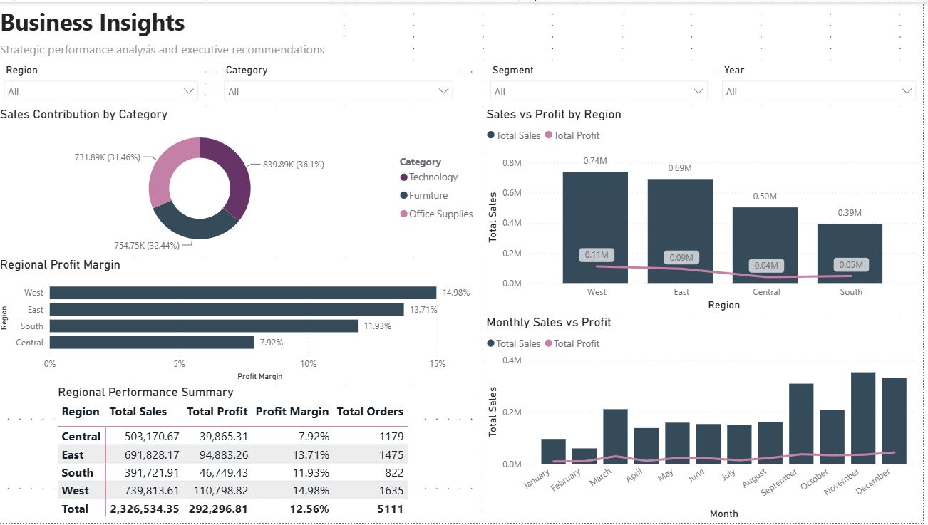
Figure 8.4: Business Insights Dashboard
The page includes:
Sales vs Profit by Region
This visualization compares sales and profit across the four regions.
It helps stakeholders determine whether higher sales are accompanied by stronger profitability.
Sales Contribution by Category
This visualization shows how different product categories contribute to total sales.
Profit Margin by Region
This visualization compares profitability relative to sales across regions.
Monthly Sales & Profit Trend
This visualization compares sales and profit over time.
Regional Performance Summary
The matrix provides a consolidated view of:
- Total Sales
- Total Profit
- Profit Margin
- Total Orders
by region.
The purpose of this page is to bring multiple performance indicators together to support management-level interpretation and decision-making.

KEY BUSINESS FINDINGS
The completed dashboard provides several important findings about the retail business.

Overall Business Performance
The dashboard reports approximately:
- Total Sales: $2.33 million
- Total Profit: $292.30 thousand
- Total Orders: approximately 5,111
- Average Sales per Order: approximately $455.20
- Profit Margin: approximately 12.56%
These indicators provide a baseline for evaluating overall business performance.
The results show that the business generates substantial sales revenue while maintaining a positive overall profit margin.

Regional Performance
The regional analysis identifies West as the strongest region in terms of sales.
The regional results are approximately:
Region | Sales | Profit | Profit Margin
West | $739.81K | $110.80K | 14.98%
East | $691.83K | $94.88K | 13.71%
Central | $503.17K | $39.87K | 7.92%
South | $391.72K | $46.75K | 11.93%

The West region therefore demonstrates both strong revenue generation and a relatively strong profit margin.
The Central region requires particular attention because its profit margin is substantially lower than that of the other regions despite generating a significant level of sales.

Category Performance
The category analysis shows that Technology is the leading category in terms of sales contribution.
This indicates that Technology products represent an important source of revenue and should therefore receive appropriate attention in areas such as inventory planning, product availability, pricing, and promotional strategy.

Customer Segment Performance
The dashboard indicates that Consumer is the largest customer segment by sales.
This suggests that Consumer customers represent an important contributor to overall revenue.
However, sales contribution alone should not be used as the only measure of customer value. Future analysis could also consider customer profitability, purchase frequency, and retention.

Shipping Performance
The Sales by Ship Mode analysis indicates that Standard Class is the dominant shipping method by sales.
This provides useful operational information because shipping represents an important part of the customer order fulfillment process.

Discount and Profitability
The Discount vs Profit analysis provides a visual method for examining the relationship between discount levels and profitability.
The analysis highlights the importance of monitoring discounting practices because higher discounts may affect profit performance.
Therefore, discount decisions should be evaluated using both sales performance and profitability rather than sales volume alone.

BUSINESS RECOMMENDATIONS
Based on the findings from the dashboard, the following recommendations are proposed.

Investigate Central Region Profitability
The Central region has a relatively low profit margin of approximately 7.92%.
Management should investigate the underlying causes, including:
- discount levels
- product mix
- pricing
- operational costs
- customer/product profitability
The objective should be to identify why the region converts sales into profit less effectively than stronger-performing regions.

Maintain and Learn from West Region Performance
The West region demonstrates strong sales performance and a high profit margin.
Management should identify the factors contributing to this performance, such as successful products, customer segments, pricing approaches, and sales strategies.
Where appropriate, successful practices could be evaluated for application in weaker-performing regions.

Prioritize High-Performing Product Categories
Technology represents the largest contributor to sales.
Management should monitor:
- product availability
- inventory levels
- pricing
- product assortment
- promotional activity
Maintaining availability of high-performing products can help protect an important source of revenue.

Review Discounting Strategy
The relationship between discount and profit should be monitored carefully.
Management should assess whether higher discounts generate enough additional sales to compensate for reduced profit margins.
A more controlled discount strategy could help improve profitability while maintaining competitive sales performance.

Develop Customer-Focused Strategies
Since Consumer customers represent the largest sales segment, management could develop targeted strategies for this group.
Potential approaches include:
- personalized promotions
- product recommendations
- customer retention initiatives
- targeted campaigns
However, future analysis should also evaluate profitability by customer segment before allocating additional resources.

Monitor Regional KPIs Regularly
The Regional Performance Summary provides an effective framework for ongoing monitoring.
Management should periodically review:
- Sales
- Profit
- Profit Margin
- Order Volume
This would allow performance changes to be identified earlier and support more proactive decision-making.

CONCLUSION
The Retail Sales Performance Analysis Dashboard successfully transforms retail transaction data into an interactive Business Intelligence solution.
The project combines data preparation, data modeling, DAX-based KPI development, and interactive visualization to provide a comprehensive view of retail business performance.
The four dashboard pages provide different levels of analysis, beginning with an executive overview and progressing into detailed sales, customer, product, profitability, and regional analysis.
The analysis identified several important business patterns, including the strong performance of the West region, the significant contribution of Technology products, the importance of the Consumer customer segment, and the need to investigate profitability differences across regions.
Most importantly, the project demonstrates how transactional data can be converted into information that supports business decisions. The dashboard does not only present numerical results; it provides stakeholders with an interactive method for exploring performance and identifying areas that may require further investigation.
Future improvements could include incorporating additional customer profitability metrics, time-based year-over-year comparisons, forecasting, retention analysis, and more detailed cost information. These enhancements would provide an even deeper understanding of the factors driving sales and profitability.
Overall, the project demonstrates the practical application of Power BI, Power Query, DAX, data modeling, business analysis, and data-driven decision-making within a retail business context.

